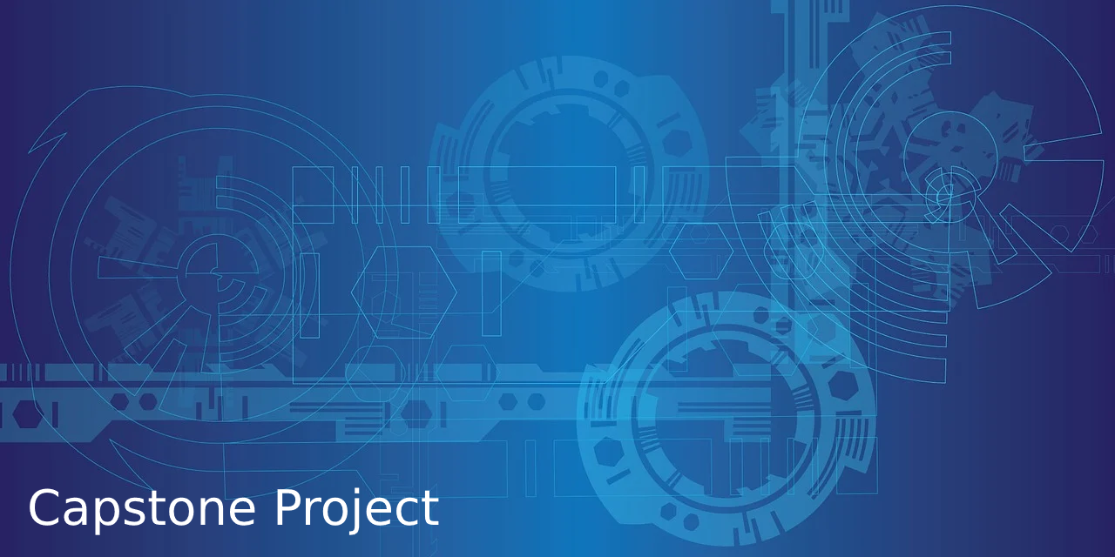

**Assistive Technology for Diverse Learners**

**Closure Report**

**Sunnyside Middle School**

|  |  |
| --- | --- |
| Proposal prepared by | Alexandra Washington |
| Contact email | [alexwashington@student.purdueglobal.edu](mailto:alexwashington@student.purdueglobal.edu) |
| Preparation date | December 12, 2023 |

**Project Overview**

The purpose of this project is to provide diverse learners with technology to assist in their learning. Diverse learners will be provided with an equitable learning experience throughout their middle school learning. Teachers and parents will be provided with assistance while teaching their diverse learners. Administrators will be able to save money toward curriculums in the future.

The goal of this project was to replace and update old technology and implement new technologies in Sunnyside Middle School. These technologies would help students read, write, speak, and improve executive functioning. Assistive technology will help teachers provide differentiated instruction to their students with varying abilities. These new technologies are compatible with any curriculum, so there won’t be a need for modified curriculum.

There are many risks connected to new technology implementation. Student identification protection, integration, and user friendliness had the potential to cause issues. All staff, administrators, parents, and students were trained on how to protect students’ information. All present integration issues were resolved during the training process. The assistive technology will continue to be monitored regarding user friendliness.

There is still concern regarding the social impact of these technologies. Teachers are going to monitor the time spent on technology. Now that students have ways to better understand technology, it may affect how they socialize with their peers. Another social aspect is students feeling like outcasts. Teachers and administrators are taking steps to ensure that students are comfortable with using the technology in front of their peers. These issues will be monitored and addressed if necessary.

**Accomplishments**

Sunnyside Middle School had a large budget for this project. The budget included training, planning, technologies, backlogs, and set up. The budget was initially split per grade level, then later modified for the entire middle school. There was also a change in budget when the parental training was added to the schedule. The contingency fund remained full throughout the duration of the project. Overall, the budget performance was exceptional for this project. The school plans to roll over the contingency fund for next year. These funds may be used on more assistive technology, training, or curriculum upgrades.

This project took 4 weeks to complete. The scheduling had minor adjustments when the parental training was added. This addition added two days to the project. Aside from the training addition, all training and integration went as scheduled. Sunnyside Middle School administrators made extra efforts to ensure all stakeholders attended training. All staff and administrators were able to make their designated training times.

The project team was able to implement each technology. The software and hardware updates went smoothly, making it easy to focus on integration. Each diverse learner was assigned to the necessary assistive technology. Teachers were trained and were able to create processes for integration in their classrooms. Teachers and administrators were provided with methods to monitor the new assistive technologies.

**Lessons Learned**

There were several things that could have gone wrong during this project. Starting with scheduling: there should have been more training and integration days. This was necessary because of possible absences or sick days. Luckily, the teaching staff were notified in a timely manner and made sure they were available. There were several students who were absent, and teachers were required to help them get integrated. While this worked out, it could have been mitigated if there were more opportunities for training. While it is nice that the contingency fund remained full, there could have been more money allocated to technologies.

This project had a lot of positive outcomes. The project team worked together to ensure any issues were handled appropriately. The only issues encountered were with missing data and lack of parental training. Both issues were handled or resolved within an hour. Each training session was filled with lots of questions and answers. The project was budgeted in a way that made room for mistakes. All-in-all this update and integration went smoothly.

**Recommendations for Future Projects**

This project provided Sunnyside Middle School with new technologies to serve their diverse learners. In the future, the school may focus on the quality of the technology, rather than the quantity. The school ended up getting multiple technologies based on the need. In the future, they will try getting less technologies, and focus on technologies that may supply more than one modification. This will limit the number of training sessions and responsibility for teachers. If the administration focuses on the quality, they will not need to upgrade often.

Sunnyside Middle School should try to complete projects by the first month of the school year. Many students and teachers are used to their routines and were forced to change things mid-year. The IT professional had to focus on this project instead of his usual job requirements, making it harder for him to do his job. If this were done in the summer, it would have been easier for him to complete each task. This was a great team effort all around.

**Google Drive Repository**

<https://drive.google.com/drive/folders/1LsiGcC6vKwhywpNoPIw03spVmXeGu37w?usp=drive_link>